OPERATING SYSTEMS
WEEK-3 Practical
Name:- CH. Srihitha
Roll no:- 2520030400
Section no:- 9
- Develop a C program using fork() that creates a parent and child process. Display the Process ID (PID), Parent Process ID (PPID), and process states at different stages of execution.
Design an experiment to observe process state transitions (Ready, Running, Waiting, Terminated) using Linux monitoring tools such as ps, top, and /proc. Document the observations.
Program:-
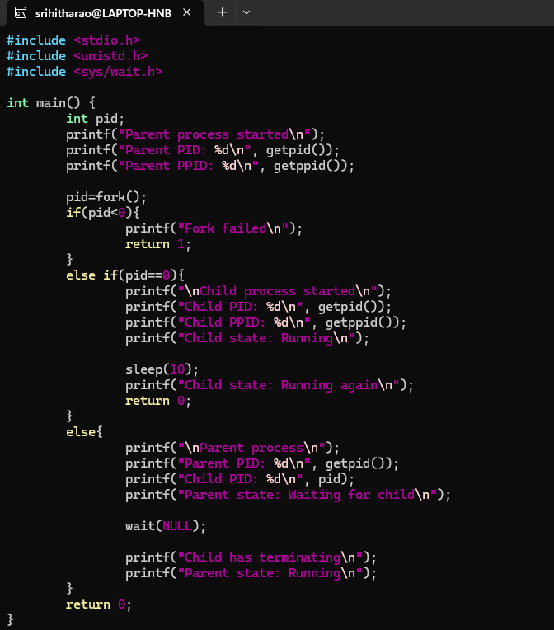

Output:-
